Final Project Proposal

1. Overview:
   * What is the problem we are trying to solve?

Many people want to find information about movies and/or series. Things like pictures, description, rating and main actors.

* + Why are we doing this?

WE can share the information they want ia a simple to search way, and giving the importante informations about each movie.

1. Who is the audience?

People who love watching movies/series, and who want to search informations about that subject.

1. List of the major functions of the application. What will it do? List these in as much detail as you can.

The main page explains the purpose of the site and the main features: search for a movie, serie or actor. A list is displayed, and when one option is clicked, a page with detailed information is displayed, like pictures, release date, rating and description.

1. Wireframes of the major views (Mobile and desktop...do the mobile wireframes first!)

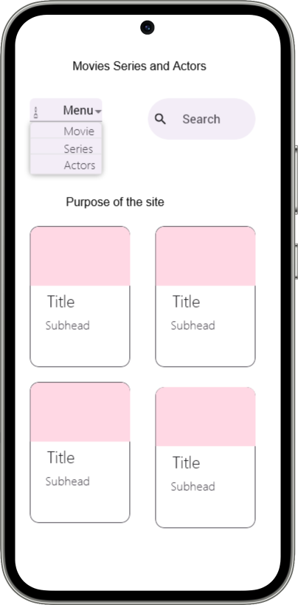

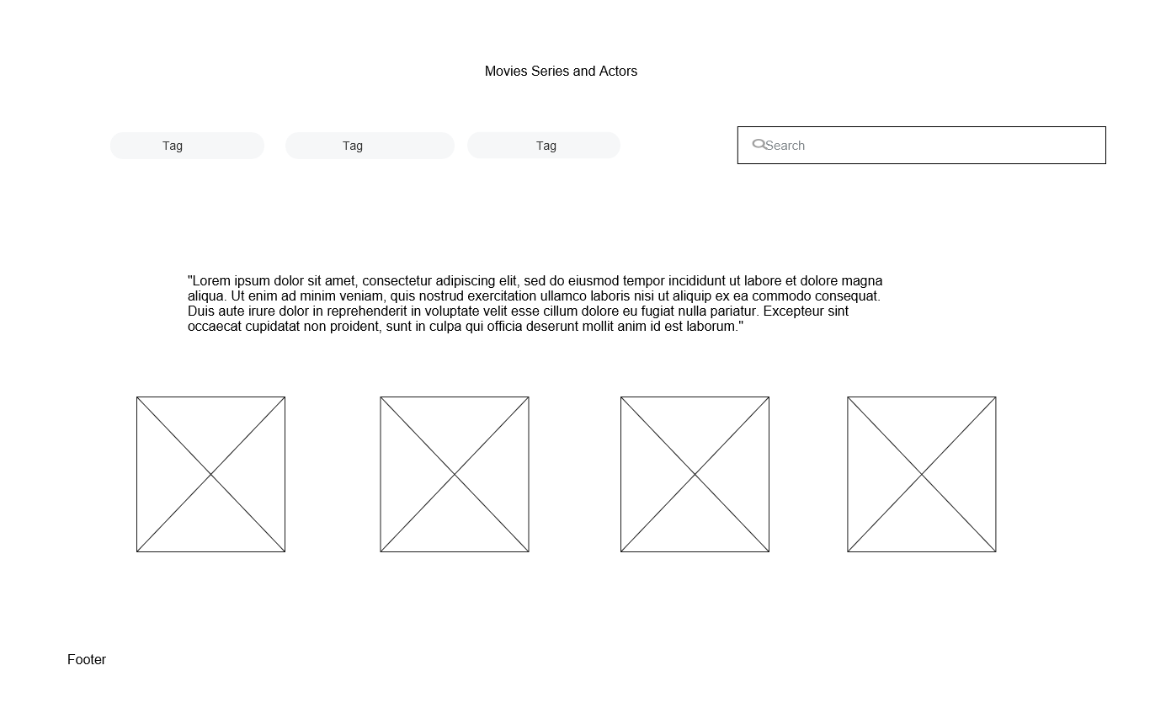

1. Data sources (External API, localStorage, local JSON file, etc.)

https://rapidapi.com/SAdrian/api/moviesdatabase/

1. Initial Module list

CSS

JS

* ExternalServices.js
* Main.js
* Movies.js
* Series.js
* Actors.js
* detailedInfo.js

Movies

Series

Actors

Partials

* Footer
* Header

Actors

1. Colors/Typography/specific element styling

Colors: black and red

Typography: Gamja Flower and Quintessential

1. Schedule to provide yourself mile markers along the way to help you stay on target.

Main page, display list, movies page, detailed info, series page, actors page, search bar

1. Link to a Trello board with all the tasks you can think of at this point defined as cards. Again be as detailed as possible here.

https://trello.com/b/jXw08M02/movies-database